Yusuf Selaboy

VUG/CSC/21/5772

Introduction to Robotics

27th April, 2024.

**Exercise 1**

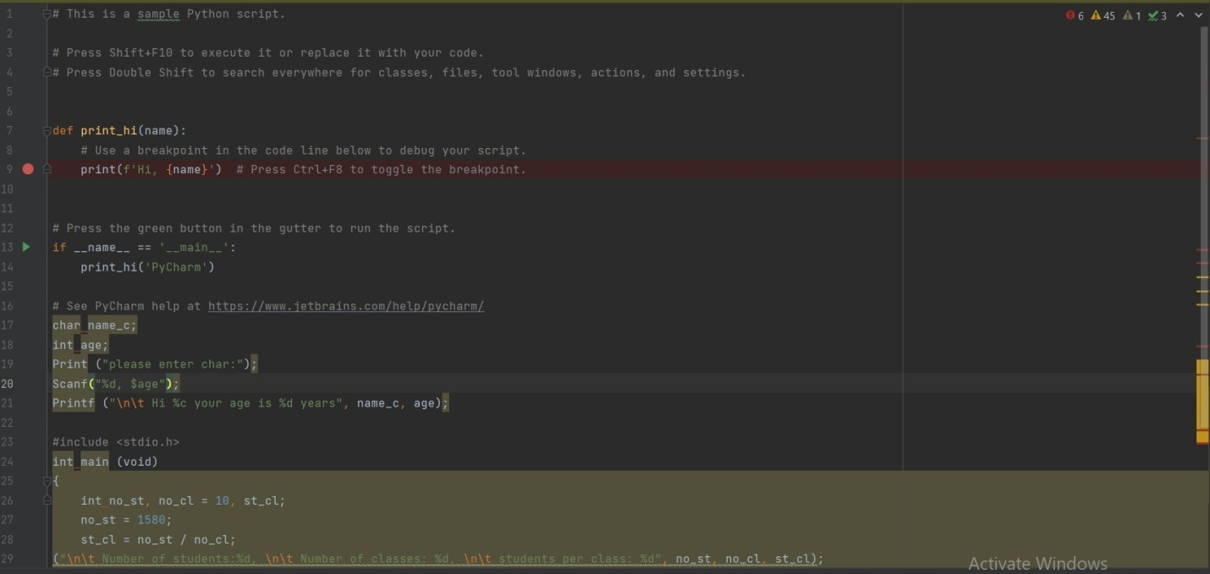

**Output**

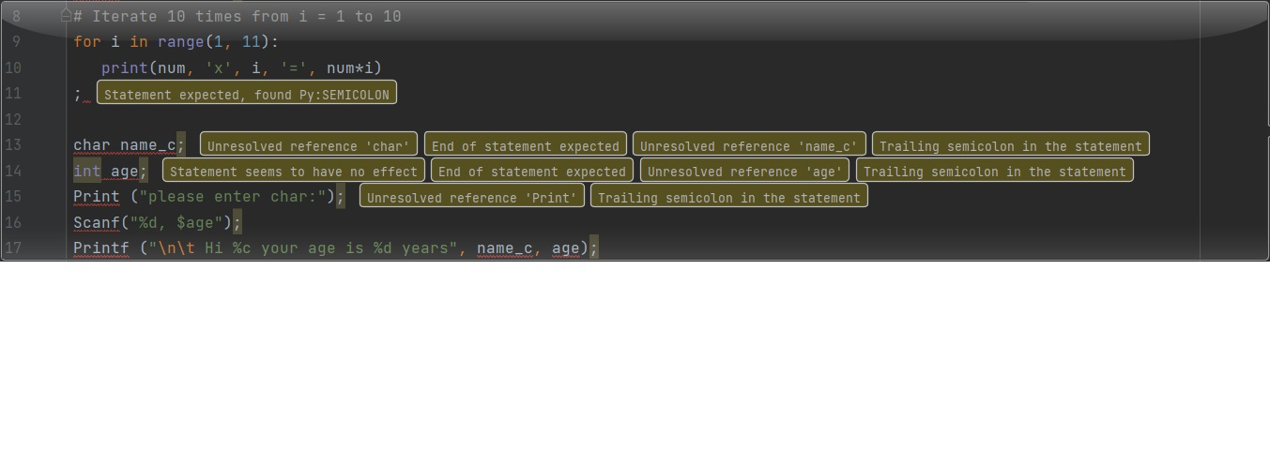

**OUTPUT 2**

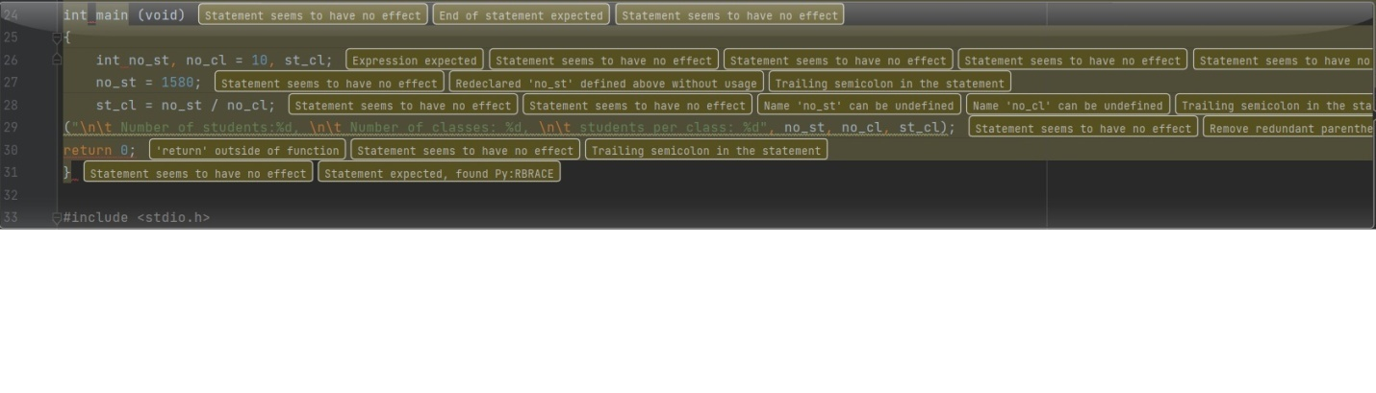

**EXERCISE 2**

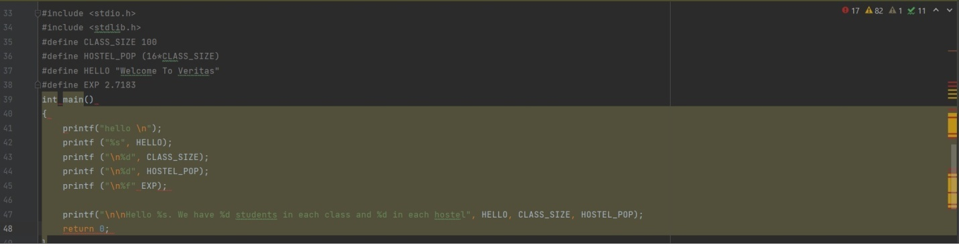

**OUTPUT 3**

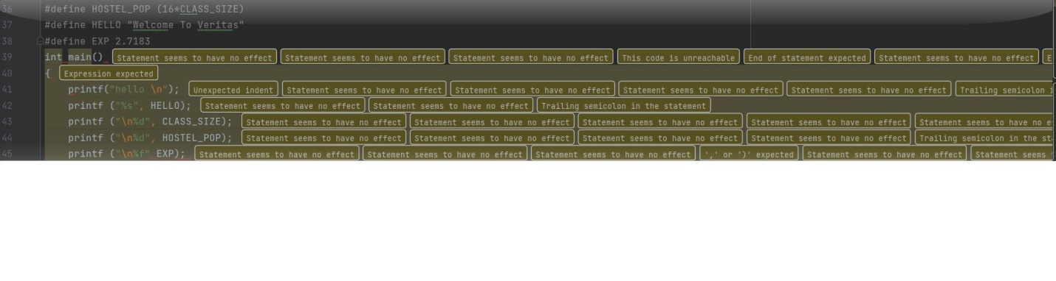

**EXERCISE 2.0**

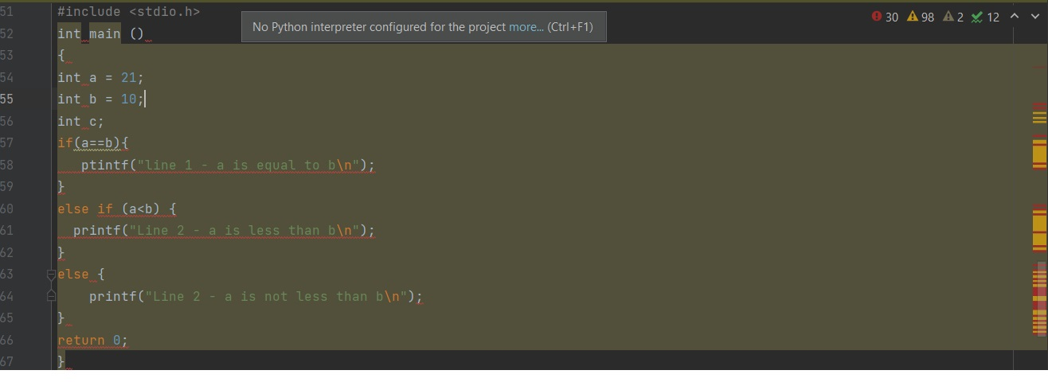

**OUTPUT 4**

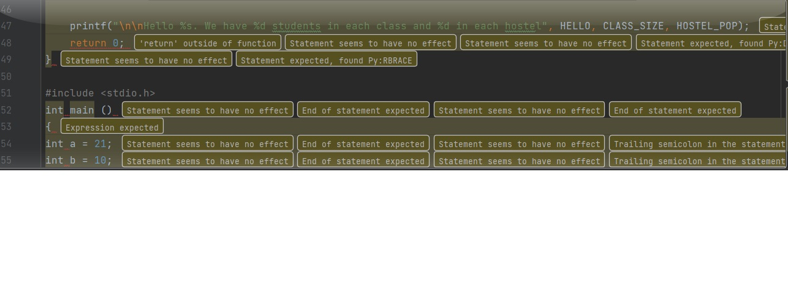

**EXERCISE 2.1**



**OUTPUT 5**



**EXERCISE 2.2**

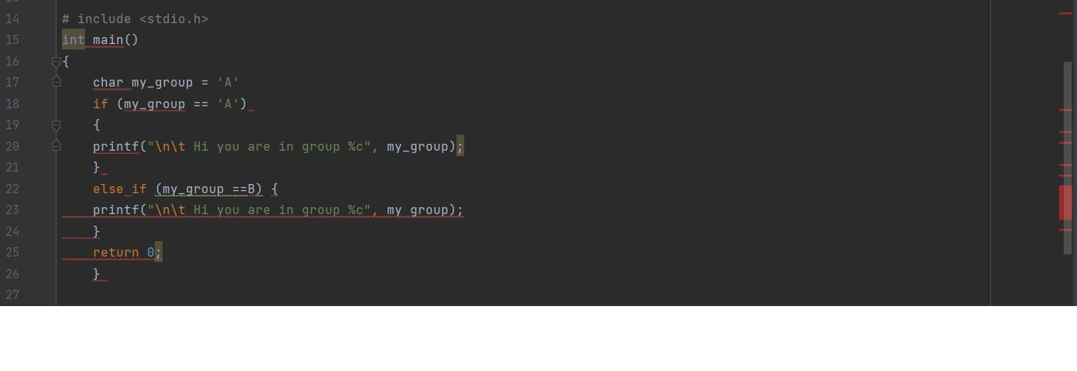

**OUTPUT 6**

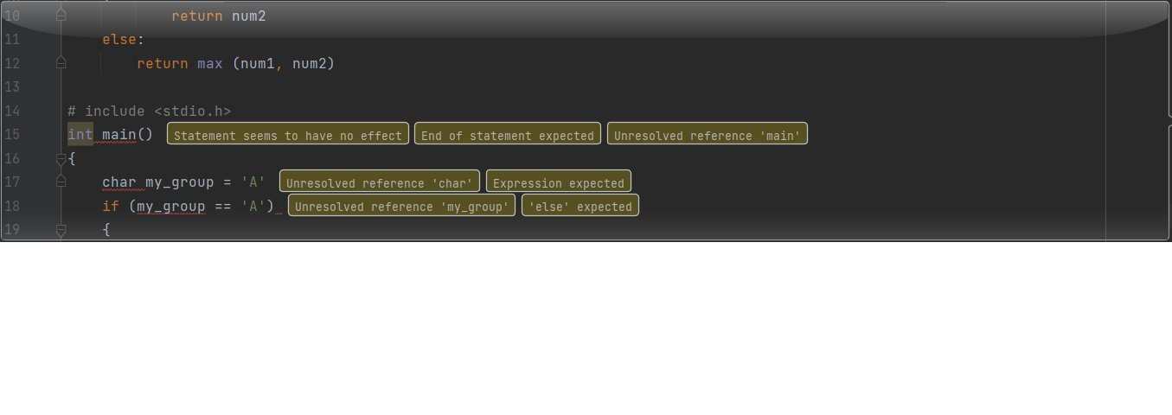

**EXERCISE 2.3**

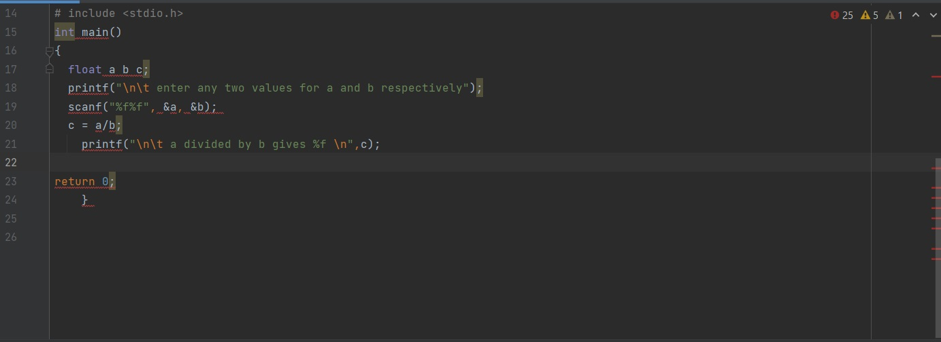

**OUTPUT 7**

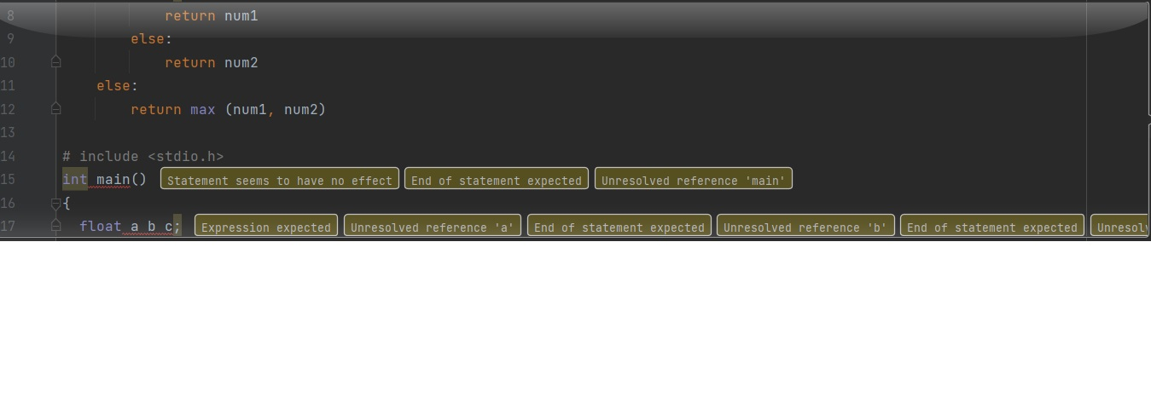

**Exercise 3**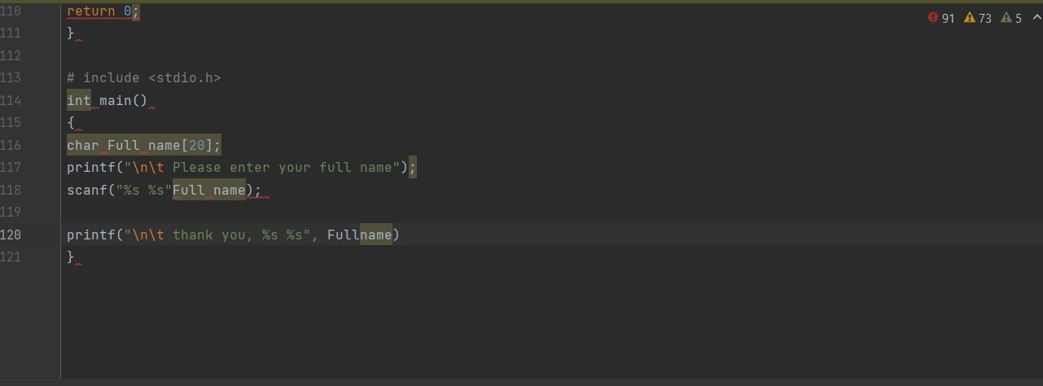

**Output**

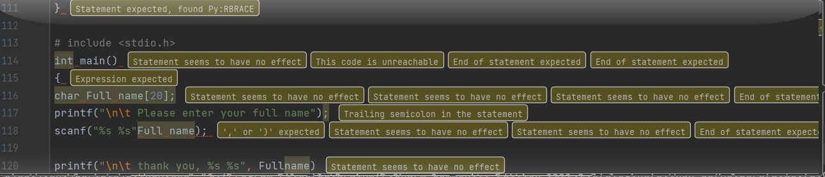

**Exercise 3.1**

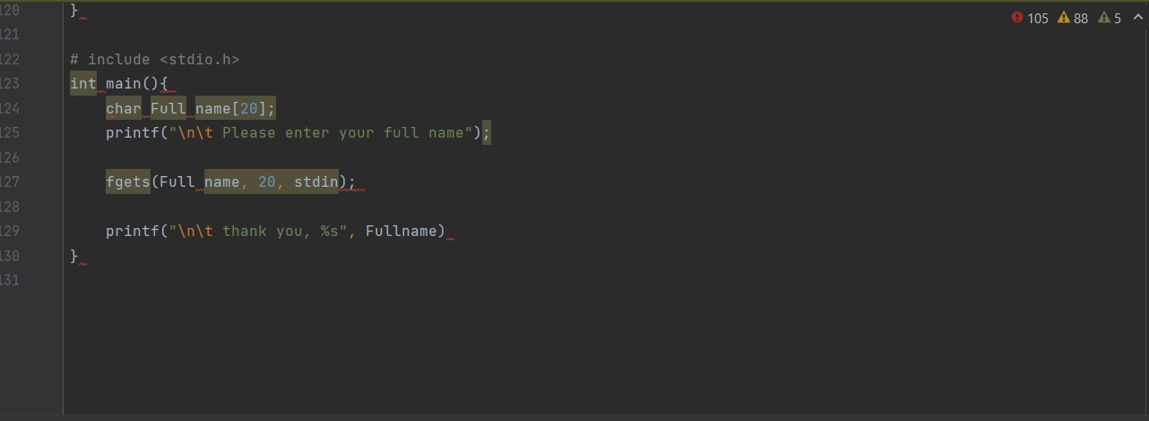

**Output**

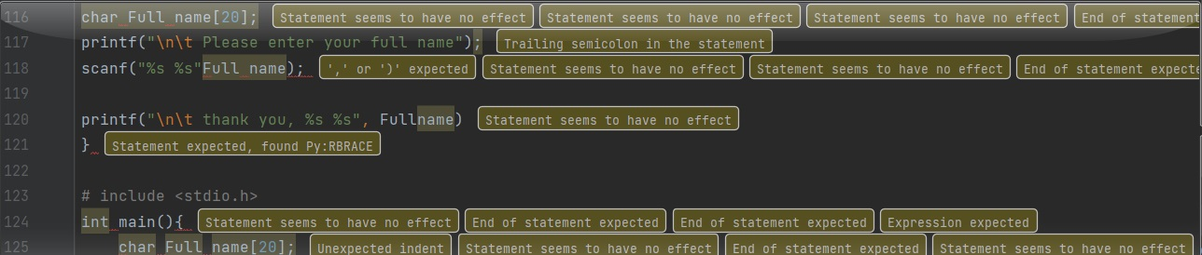

**Exercise 3.2**

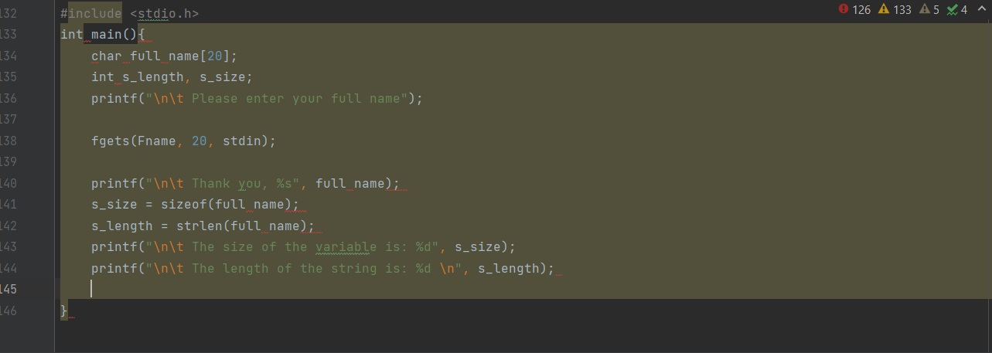

**Output**

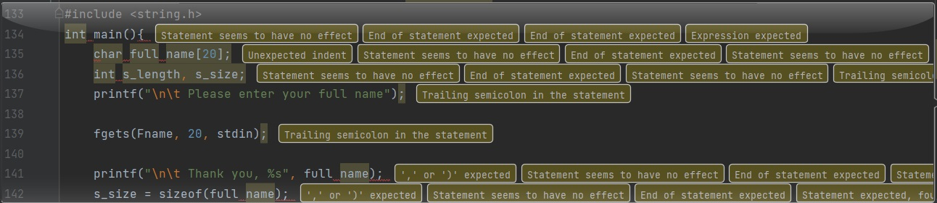

**Exercise 3.3**

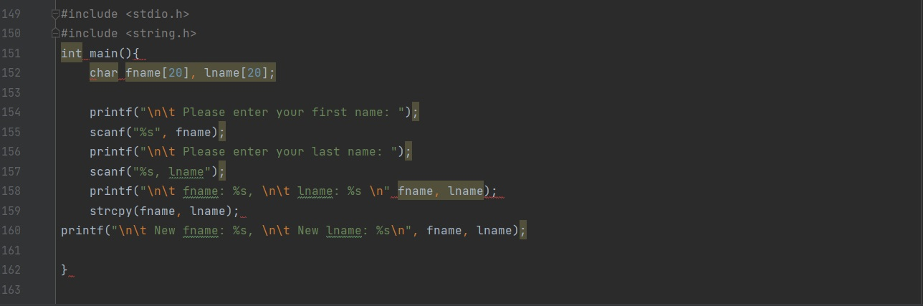

**Output**

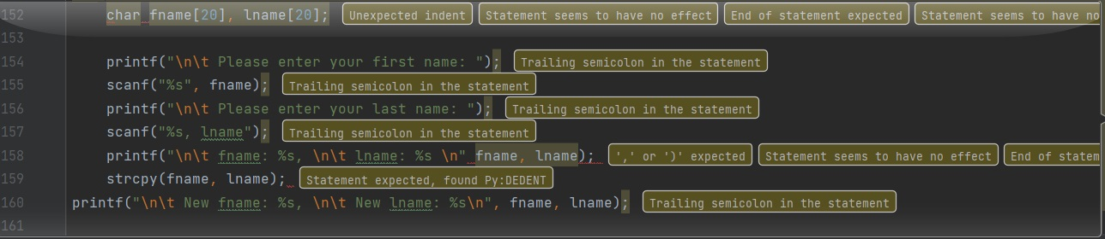

**Exercise 3.4**

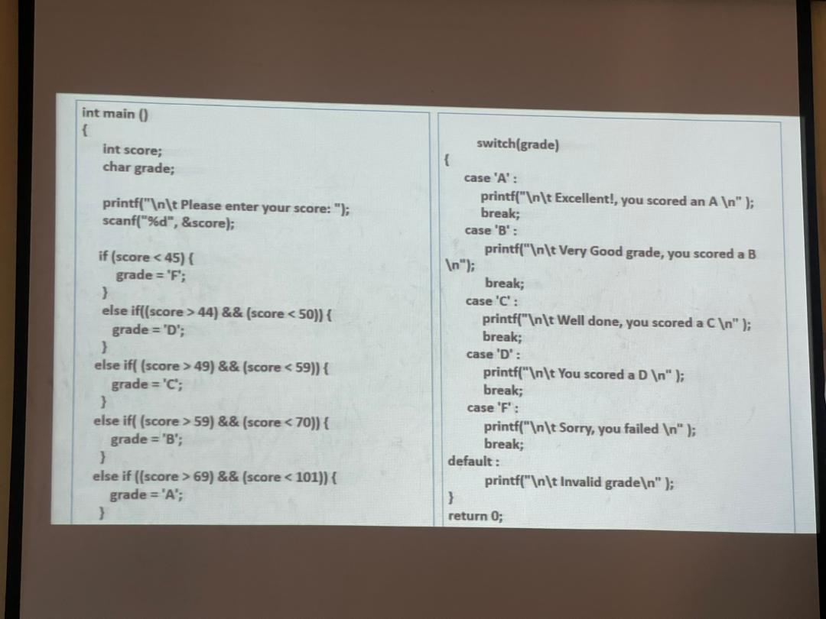

**Output**

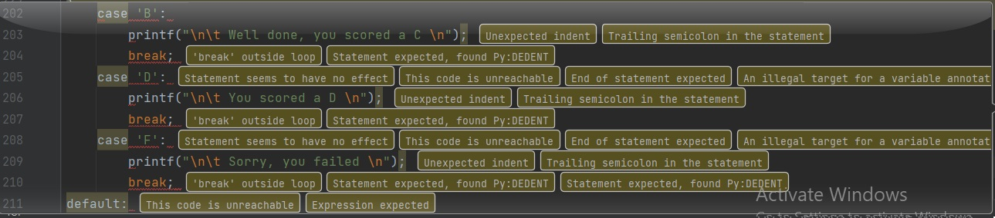

**Exercise 4**

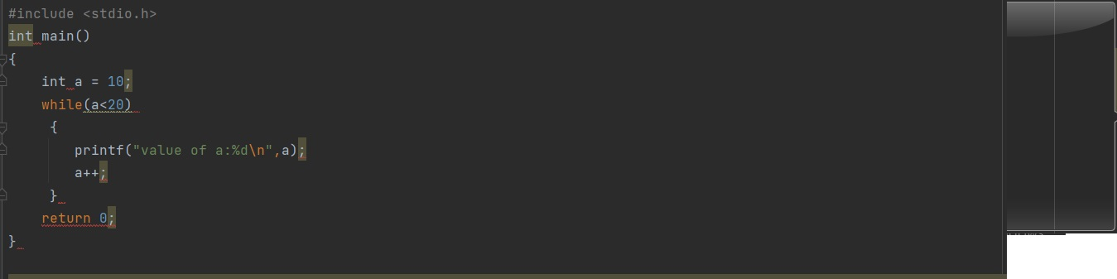

**Output**

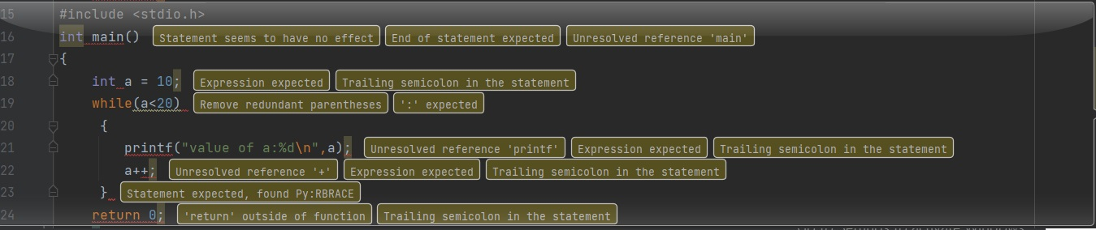

**Exercise 4.1**

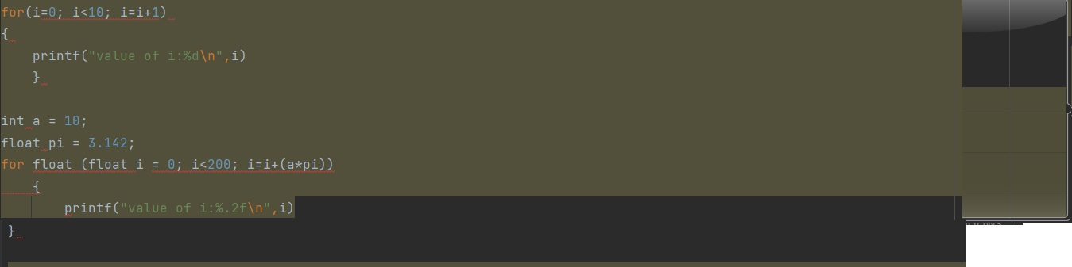

**Output**

